TECHNICAL DESCRIPTION

LIMS

Laboratory Information Management System

VERSION 1.1

IURII ABRAKHIN

T-systems

Saint-Petersburg

16.05.2019

1 Task

To develop web-application which will be modeling automated information system of medical rehabilitation institution. The application have to perform the required user’s cases.

Users cases:

For doctors

1. Add patients
2. Patient discharge
3. Prescribing procedures and medications
4. Editing prescriptions
5. Cancel prescriptions

For nurses

1. Show all events
2. Selection events by date (for today, for current hour)
3. Change event status from planned to executed or cancelled (if cancelled should be defined cause)

Remote table application which shows events for current day.

Additionally developed

1. Statistics module
2. Private page with events page for each user
3. Detailed logs which describes all data creates and updates in terms of users

2 Project goals

1. The robust, useful and reliable system for medical institution
2. Cohesive data model
3. User-friendly interface
4. Separate access to different system part
5. Ability to connect with partner systems

3 Application description

Web-application has two type of user: doctors and nurses. Nurses could view events and change events status. Doctor could add new patient, cure, diagnosis and create or modify prescription. There is authentication mechanism in system that controls access to application. Data of users and their options store in reliable data base.

4 Used technologies Instruments

Instruments

* IDE – Intellij IDEA 2018.3.5
* Maven
* SQL WorkBench
* DB – MySQL

Technologies

* EJB
* Hibernate
* Java 8
* JavaScript
* JSF
* JSP
* Junit
* Log4j
* Wildfly
* REST
* Spring
* Spring security

5 Data base diagram

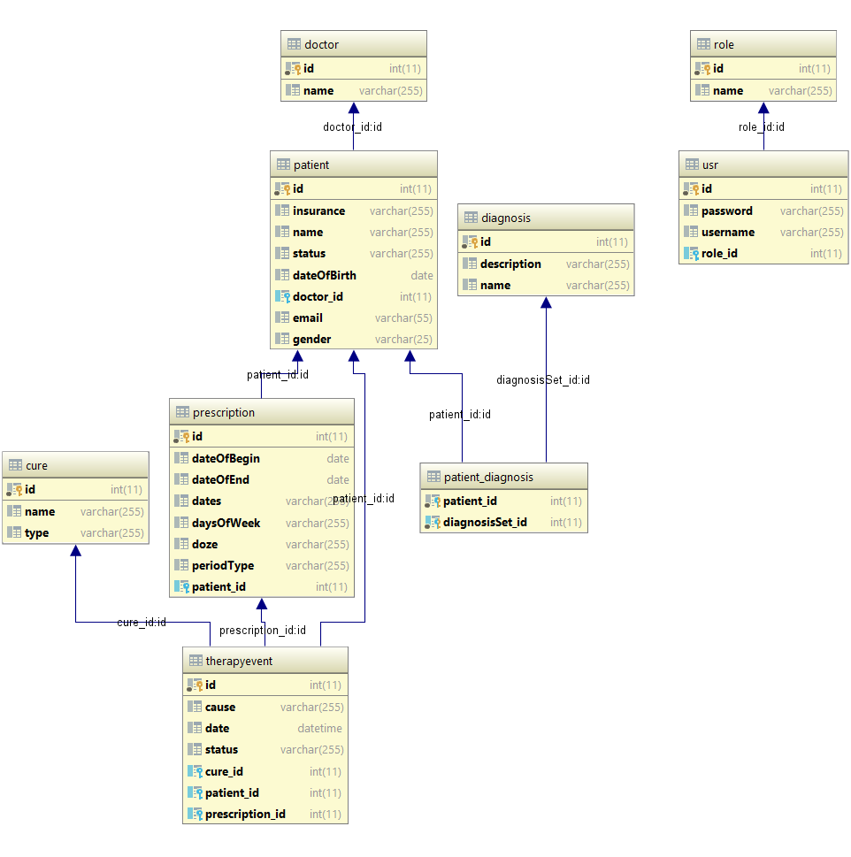

6 System architecture

6.1 Services UML diagram

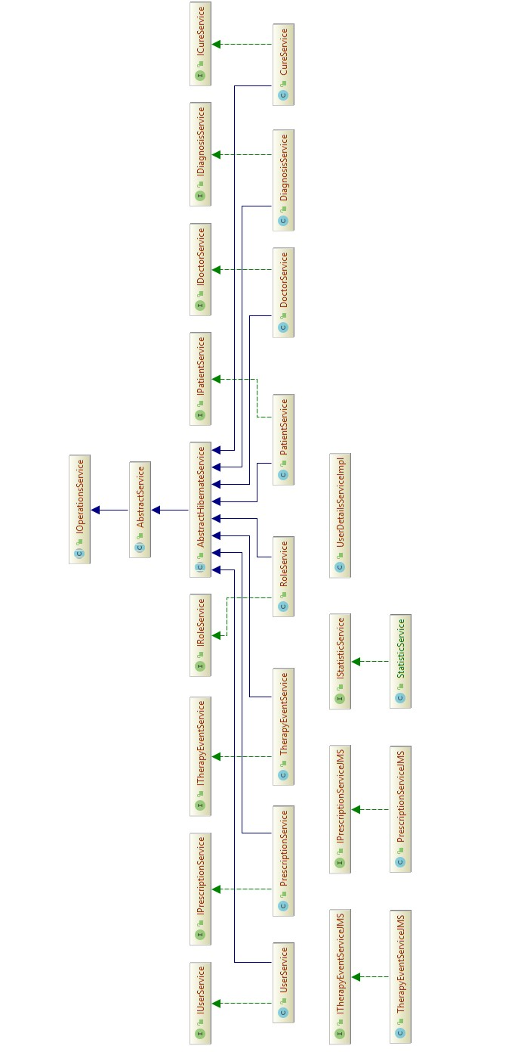

6.2 DAO UML Diagram

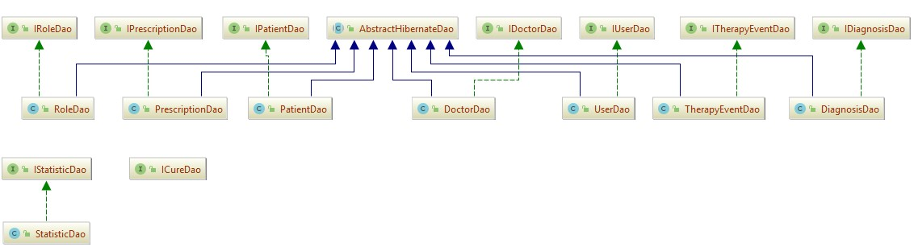

6.3 Application structure

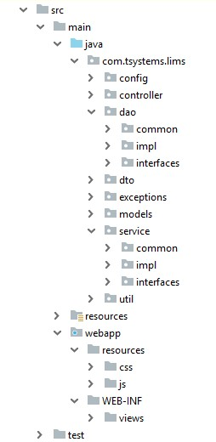

7 Additional features

1. Personal page with OAUTH 2.0
2. Infinite scroll instead of pagination
3. Statistic chart
4. User data modify log
5. UX oriented UI

8 GUI

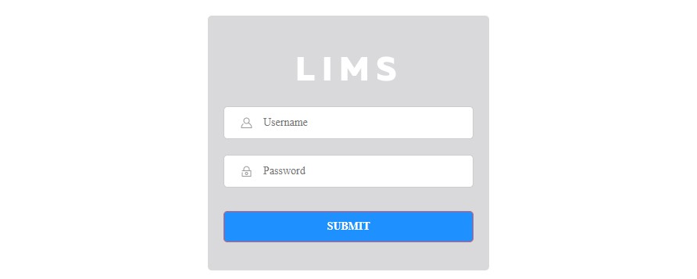

Login page

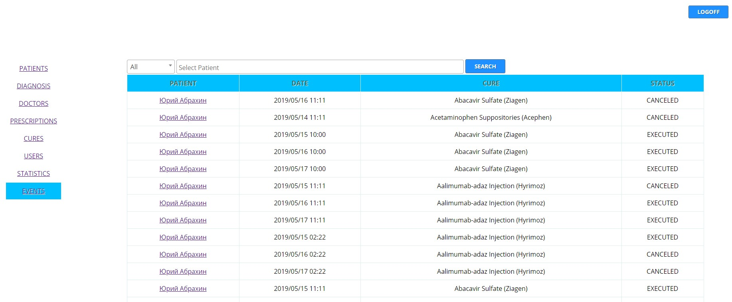

Event page

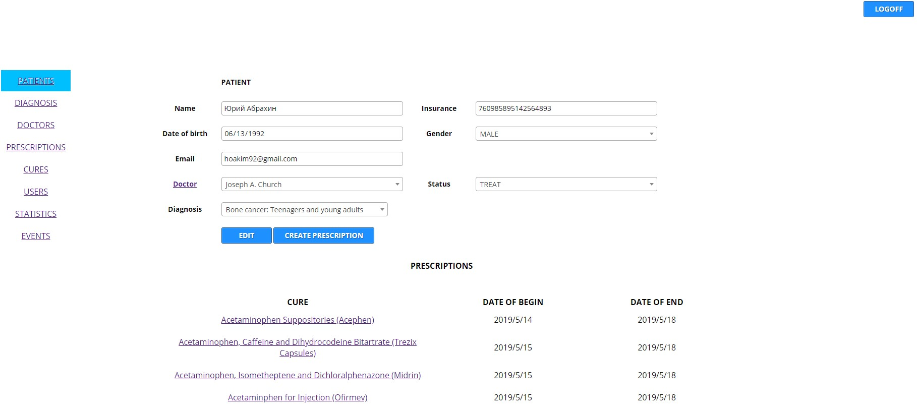

Patient page

9 Future improvement

1. Create user activity log
2. Create service for predict users issues
3. Implement microservice architecture